|  |
| --- |
| 1.  How many iterations will the following pseudocode make  to find key with value 37? integer key set integer array=[27,17,47,37,67] for ele = 0 to  step 1 do       if array[ele]equals key            display"Found"      end-if  end for  Answer  Error  0  3  4  Correct Answer  4 |
| 2.  What will the output when following programs is executed? set integer y=2 set integer z=4 display((y or z)and(z or y)  Answer  0  2  1  5  Correct Answer  1 |
| 3.  What will be the output of the following pseudocode? integer a  set float b=7.0  case 8:display"Pseudocode"                 break     default:display"Pseudo" end switch  Answer  Error  Pseudo  Pseudocode  Correct Answer  Error |
| 4.  What will the output when following program is executed? set integer x=7 set float y=7.0 if x equals y then        display "They are equal" else      display "They are unequal" end if  Answer  They are equal  They are unequal  None  Error  Correct Answer  They are equal |
| 5.  what will be the output of the following pseudocode? Set integer array=[3,7,18,9,5] set integer result=( ++array[3]) display result  Answer  7  8  10  9  Correct Answer  10 |

**Question 6**

#include<stdio.h>

int main()

{

typedef int num;

num bunk = 0.00;

printf("%d", bunk);

return 0;

}

**Options:**  
A) zero  
B) Syntax Error  
C) 0.0  
D) Logical Error

**Correct Answer: A) zero**

**Question 7**

#include<stdio.h>

int main()

{

int any = ' ' * 10;

printf("%d", any);

return 0;

}

**Options:**  
A) 360  
B) 320  
C) 340  
D) 310

✅ **Correct Answer: B) 320**

**Question 8**

#include<stdio.h>

int main()

{

int go = 5.0, num = 1*10;

do

{

num /= go;

} while(go--);

printf("%d\n", num);

return 0;

}

**Options:**  
A) compilation error  
B) Floating Point Exception  
C) 367  
D) None

✅ **Correct Answer: B) Floating Point Exception**

**9.**

#include<stdio.h>

using namespace std;

int main()

{

for (int x = 10; x >= 0; x--) {

int z = x & (x >> 1);

if (z)

printf("%d ", x);

}

}

**Options:**  
A) 679  
B) 678  
C) 763  
D) 769

✅ **Correct Answer: C) 763**

10.

#include<stdio.h>

int main()

{

int a = 100;

printf("%0 %x", a);

}

**Options:**  
A) %x  
B) %0  
C) 100  
D) 0

✅ **Correct Answer: A) %x**

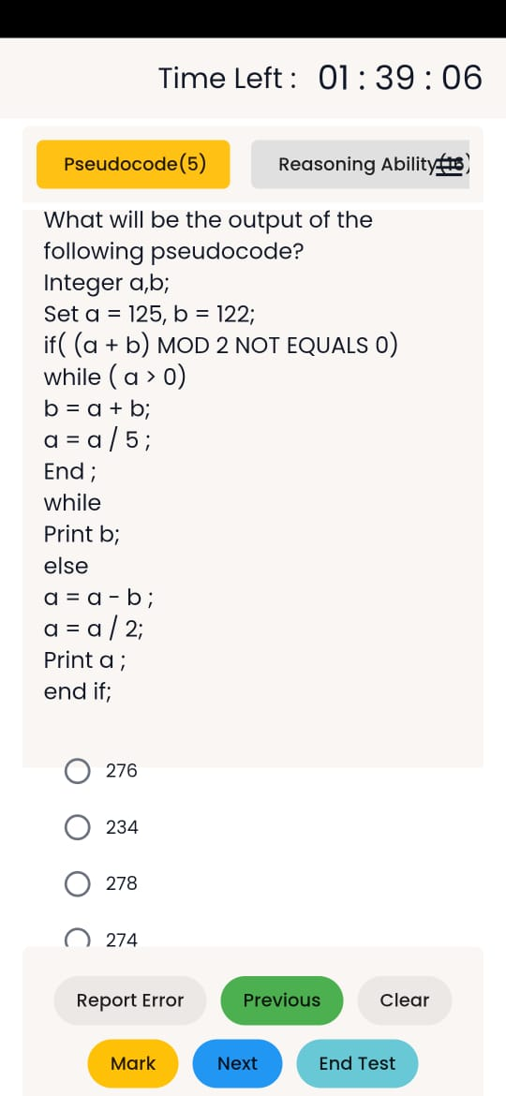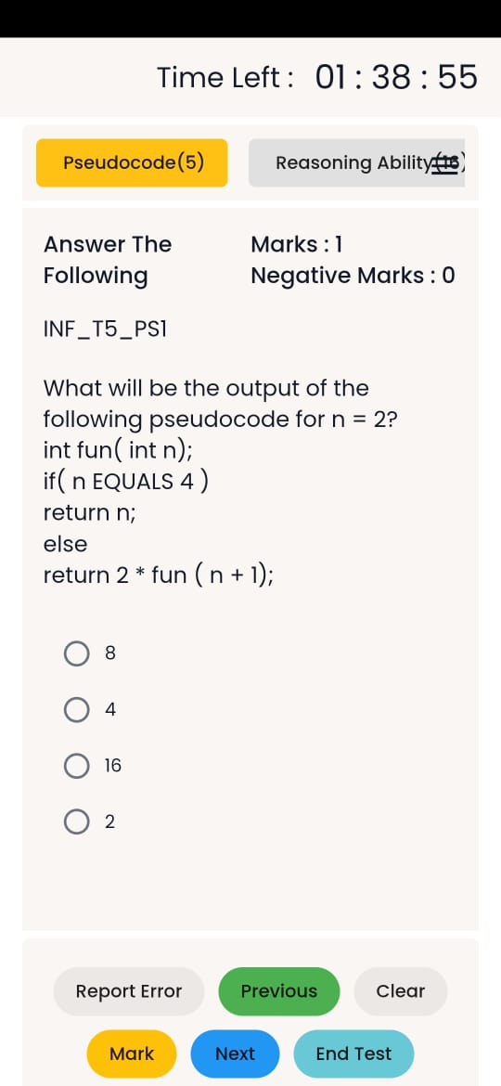

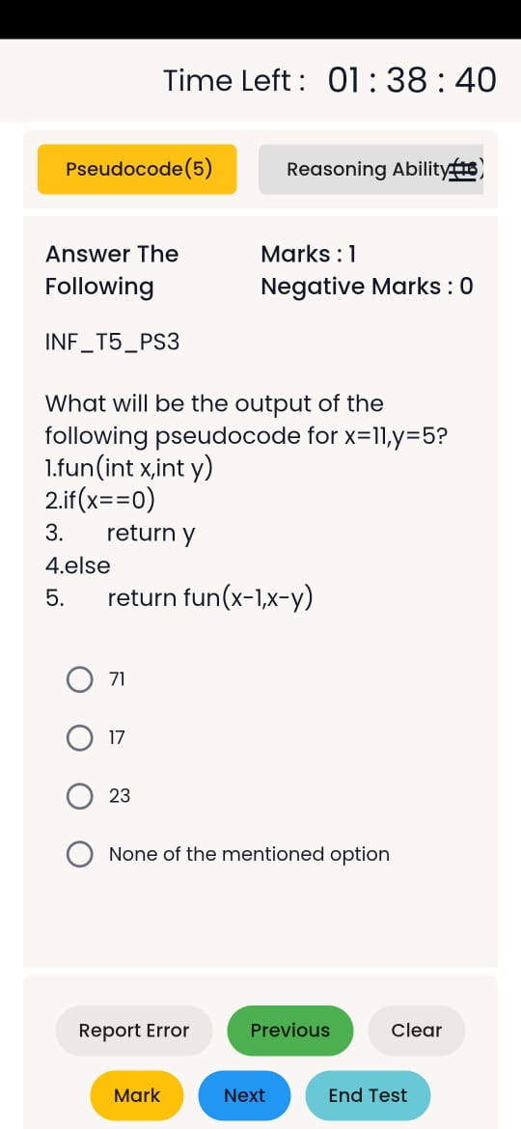

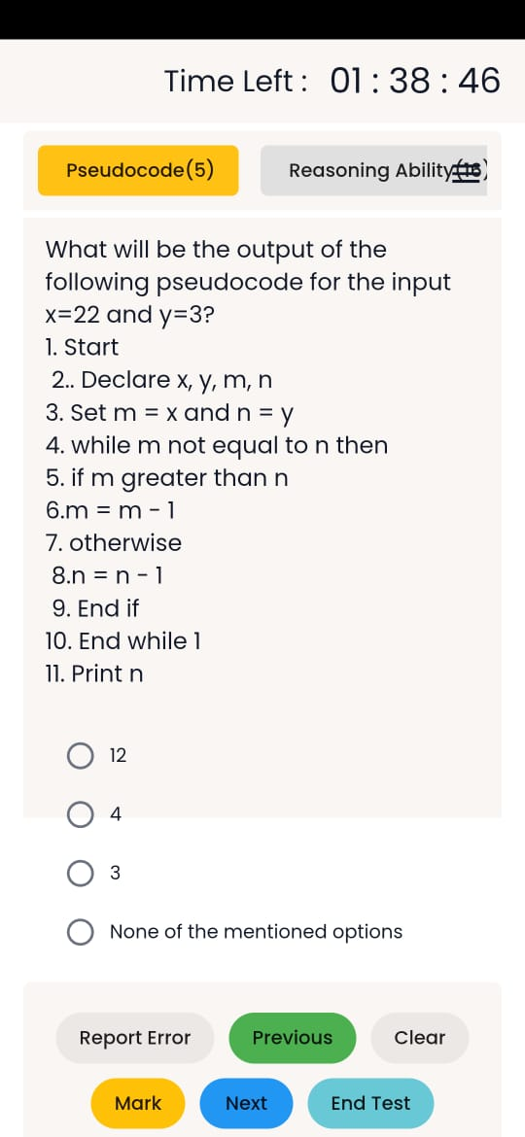

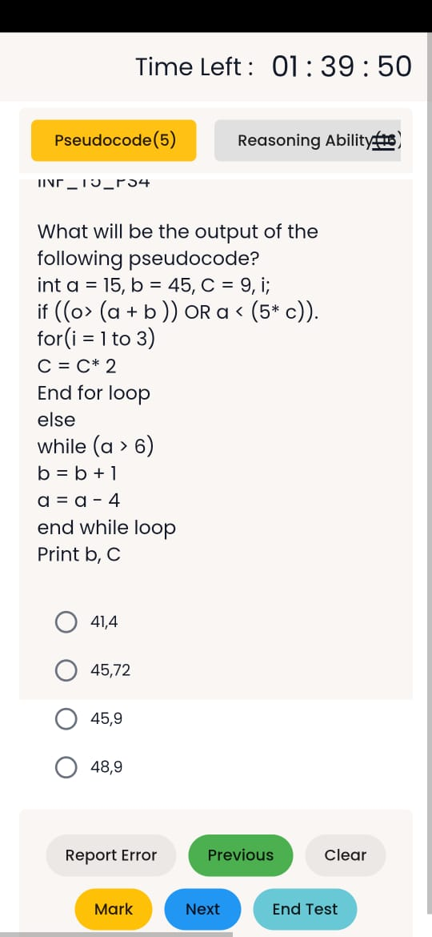

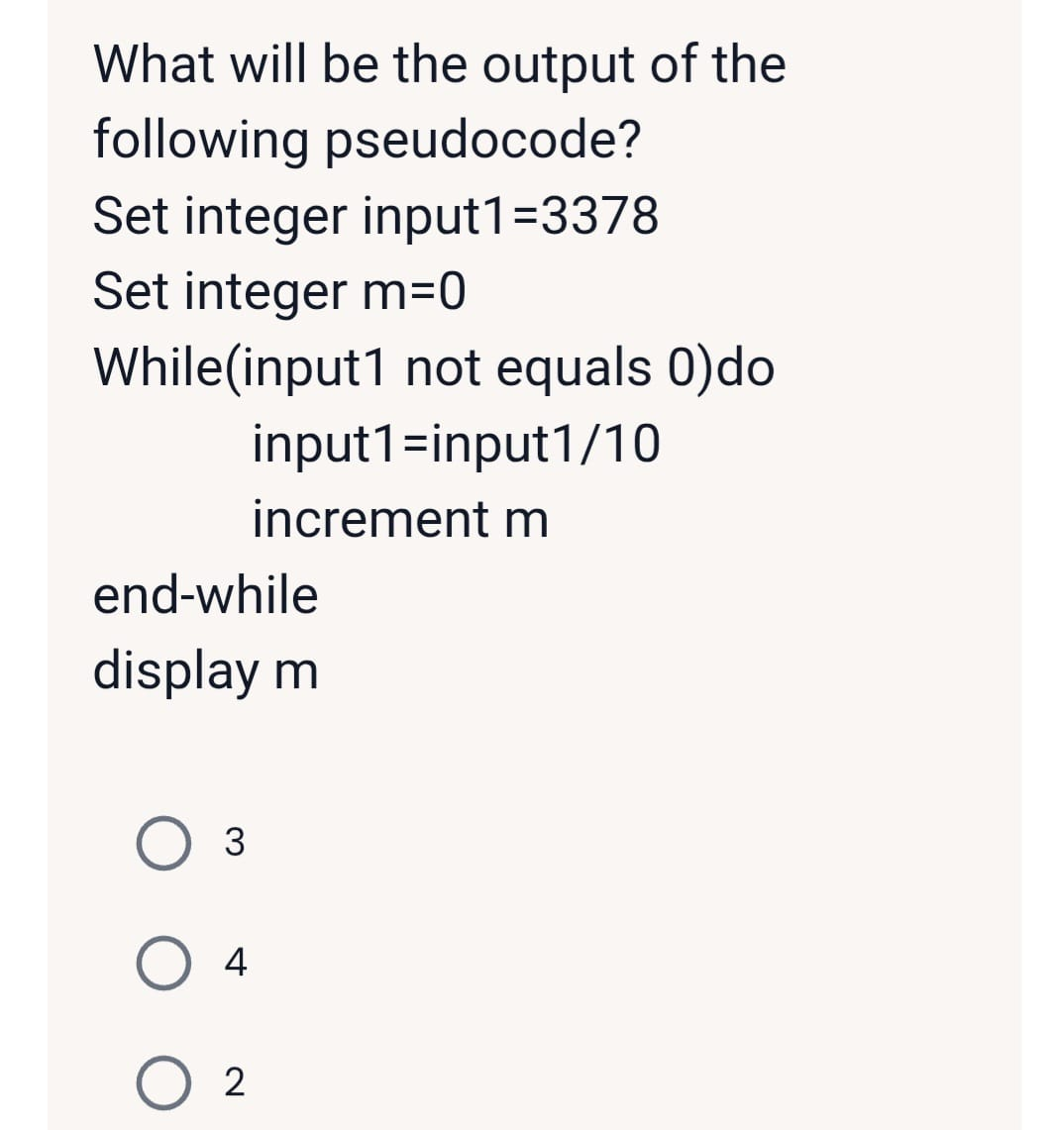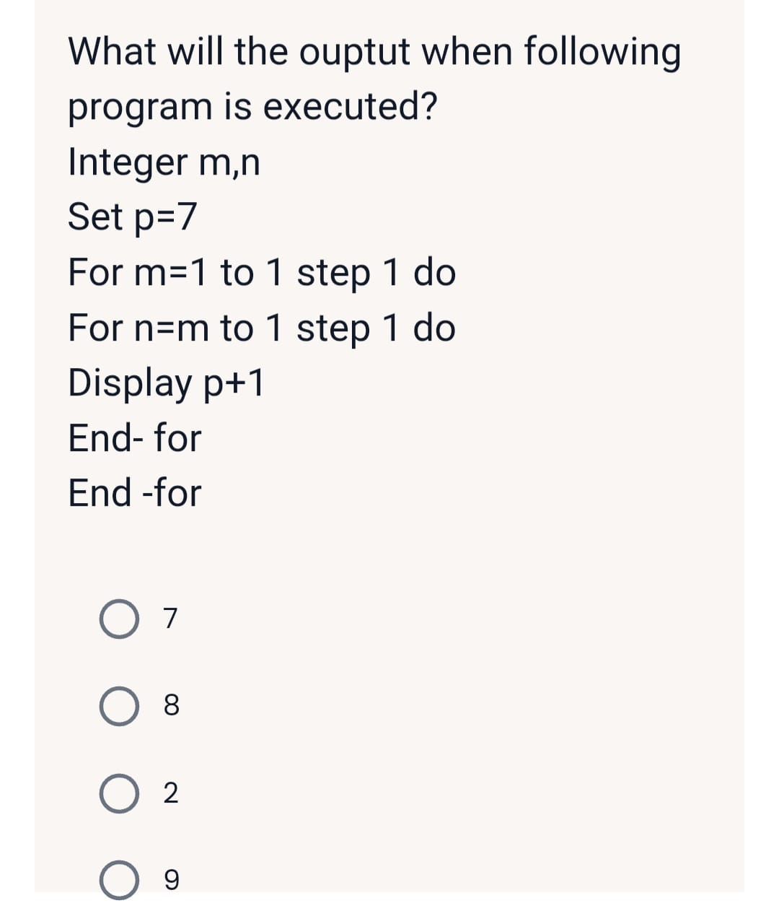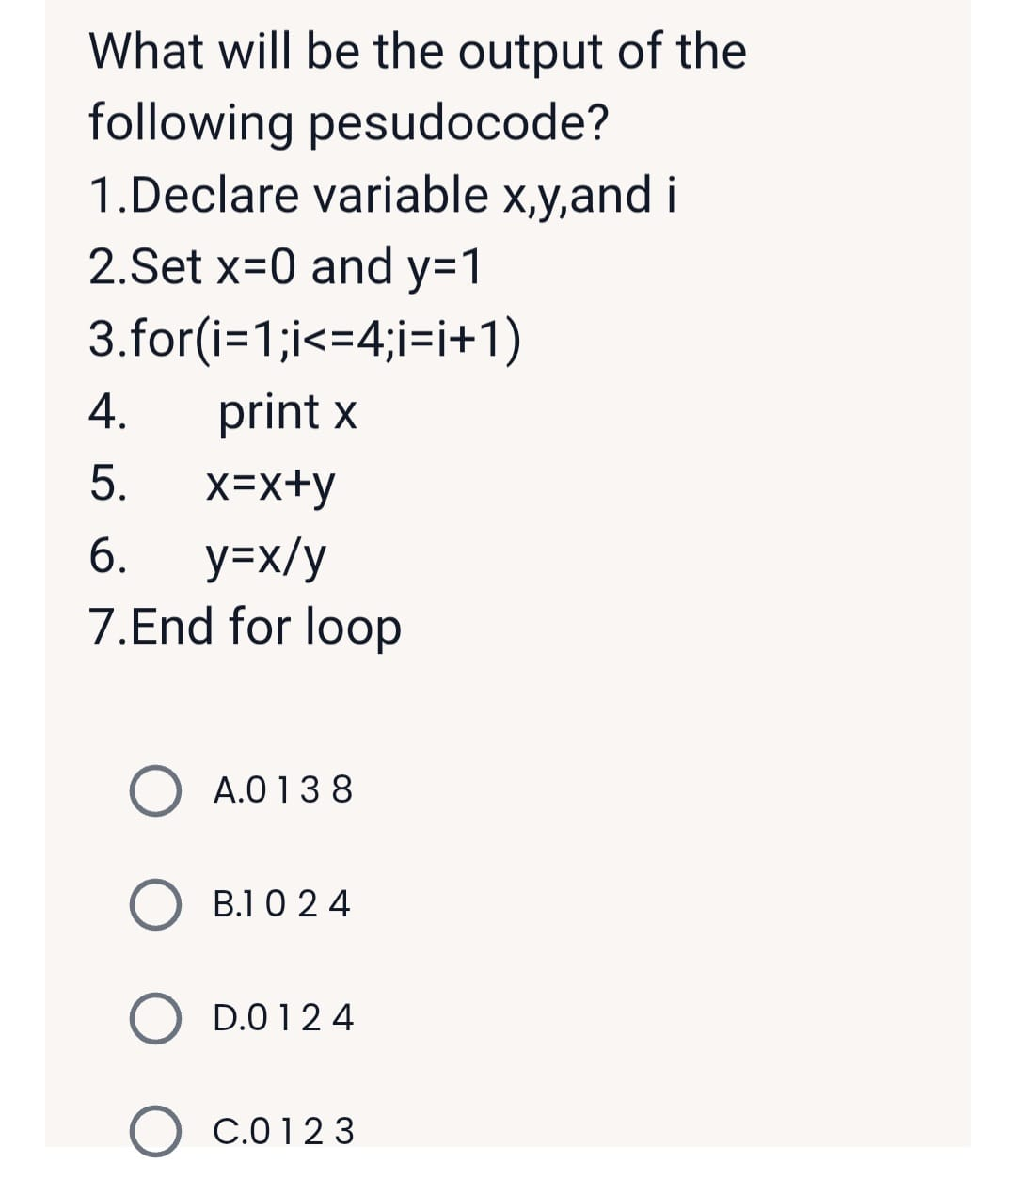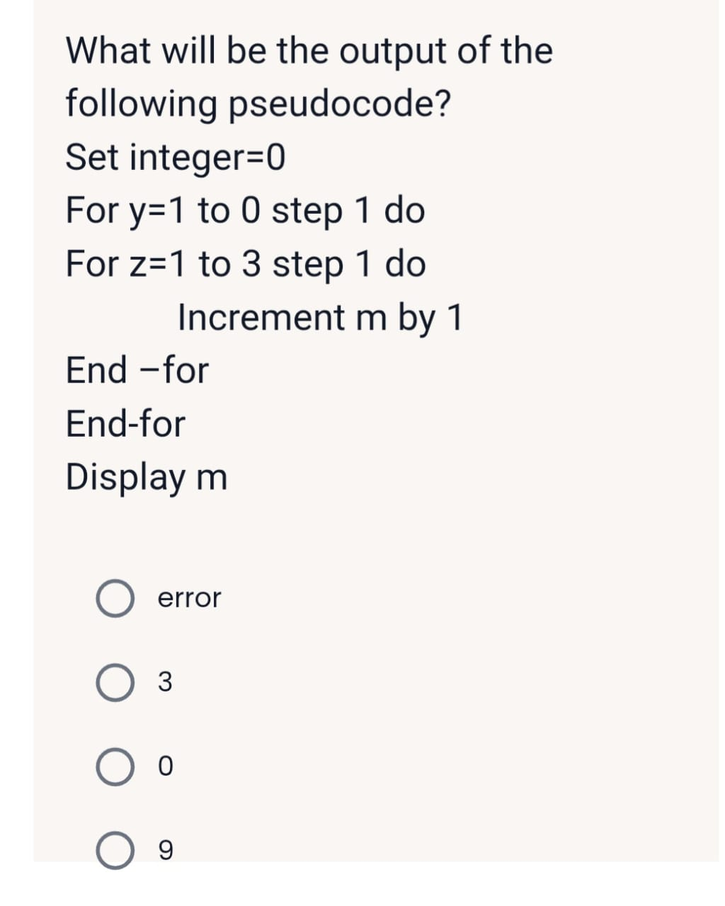

Create Integer num,sum,factor

Set num= 15,sum=0

Create for factor starts from 2 to num/2 then do

Check if (num%factor) equals zero then

Sum = sum+factor

End If

End for

Check if(sum greater than num) then

Display Abundant number

Otherwise

Display Not Abundant Number

End if